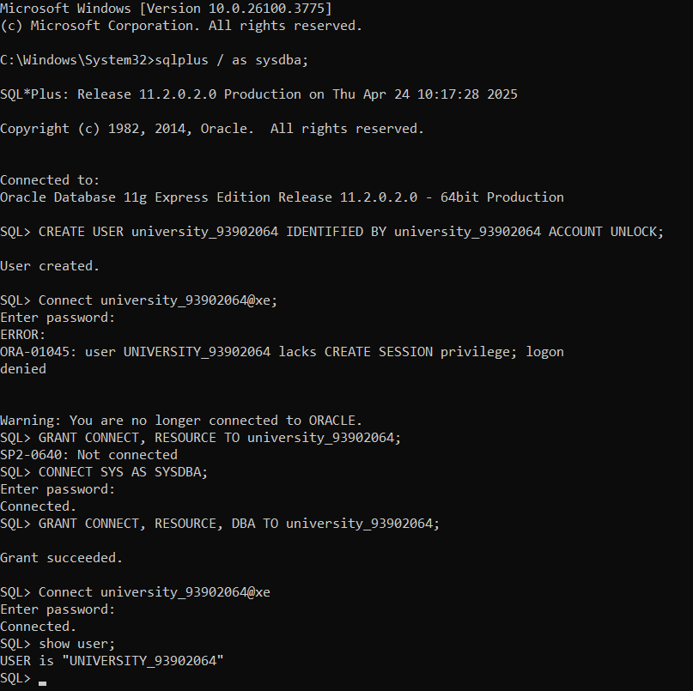 **Create a new user and grant privileges in Oracle Database**

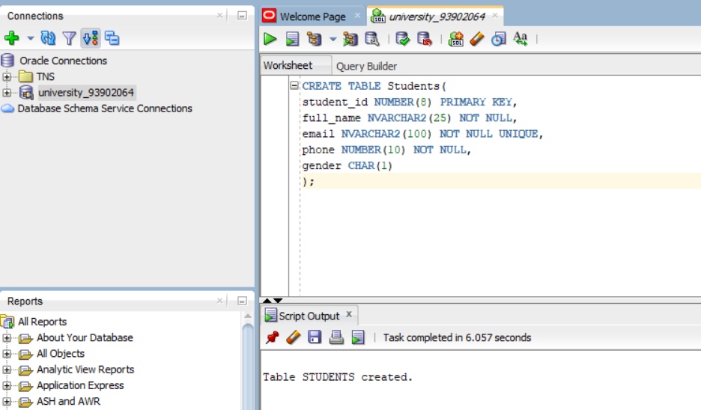**Create a Table named Students**

**View the list of Tables**

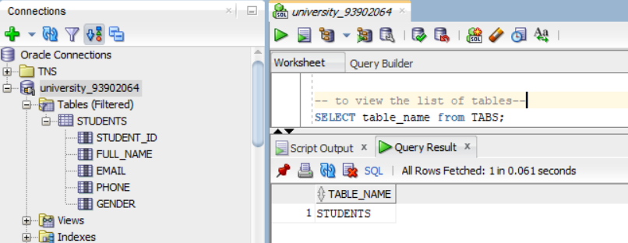

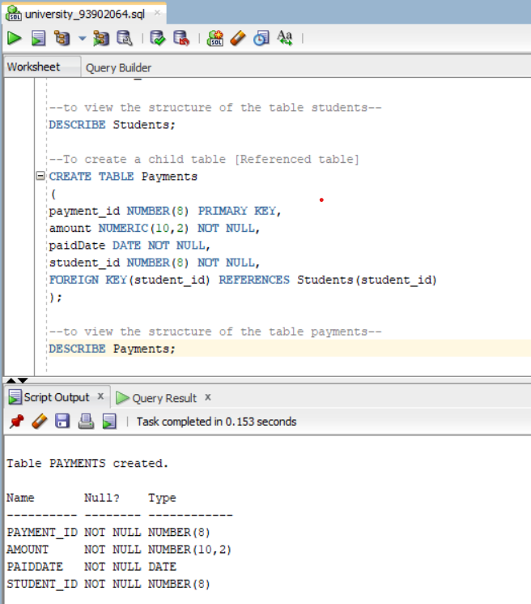**View the structure of the table and create a child table**

**View the table information and inserting into the table**

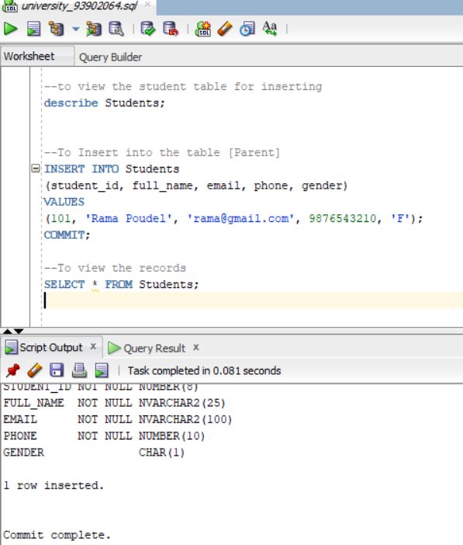

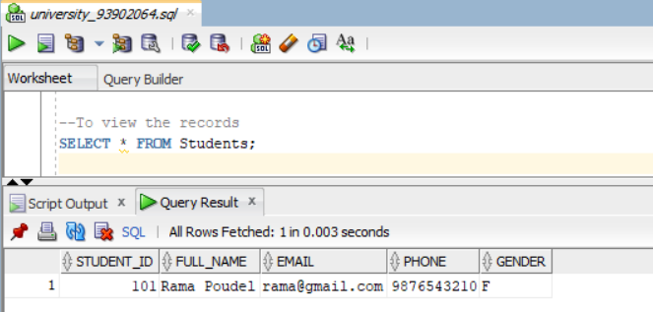**View the records in the table**

**View the structure of the table and insert into the table**

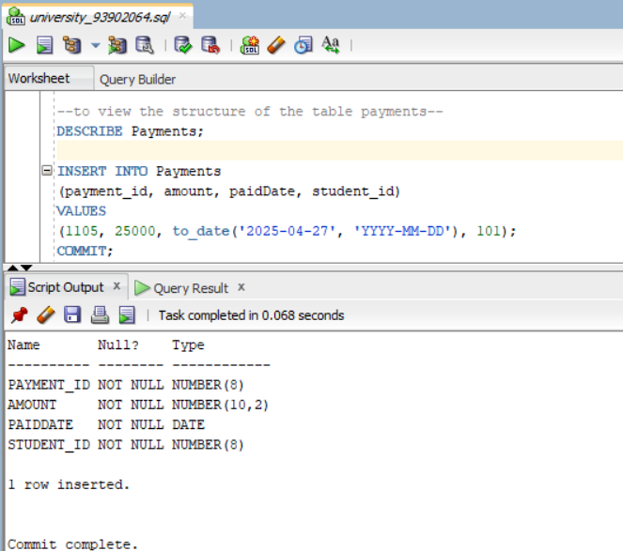

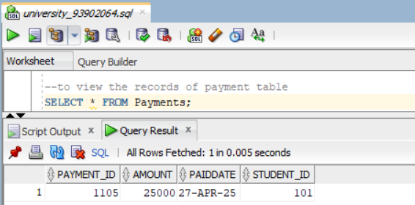**View the records in the table**

**Update the records  
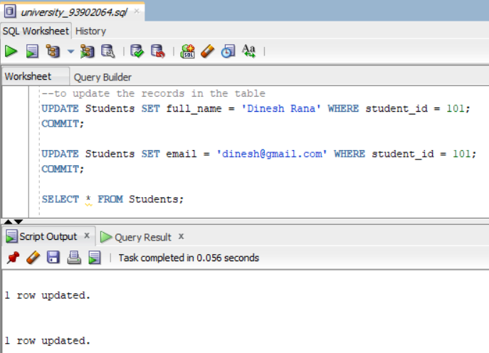**

**Delete the records with referential integrity constraint  
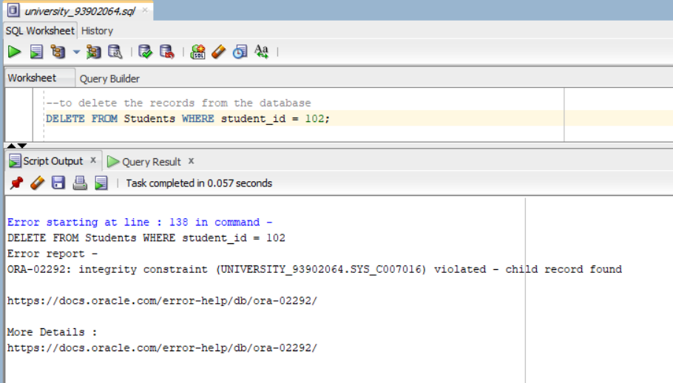**

**Delete the record without referential integrity**

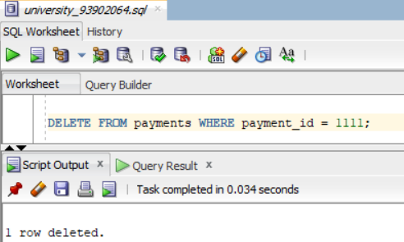

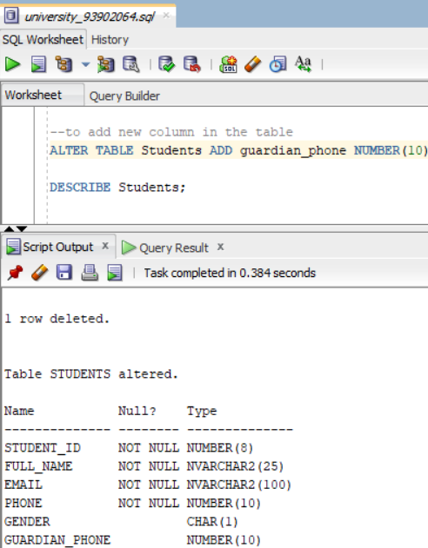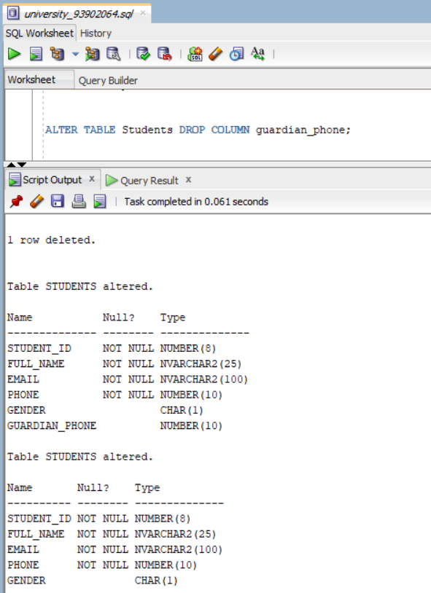**Alter table to add new column Alter table to drop the column**

**Change the datatype and column name  
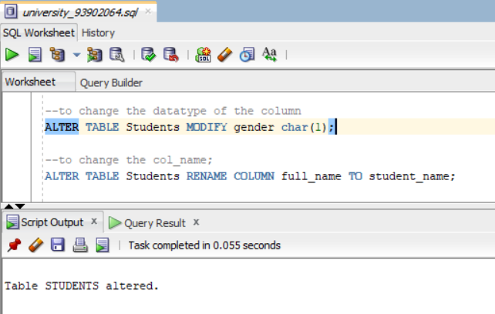**

**Remove a table from the database**

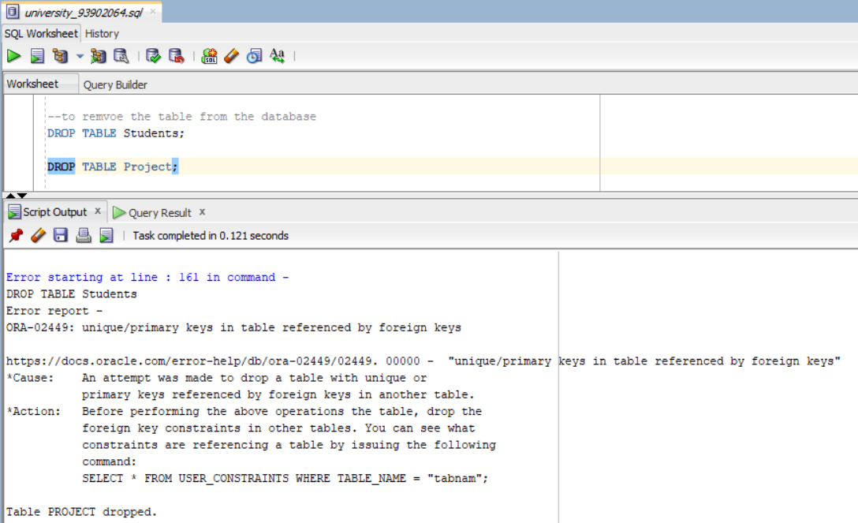

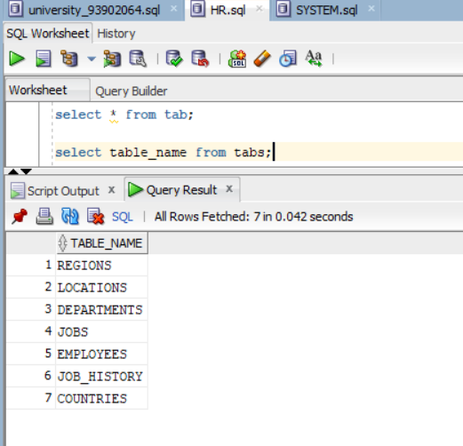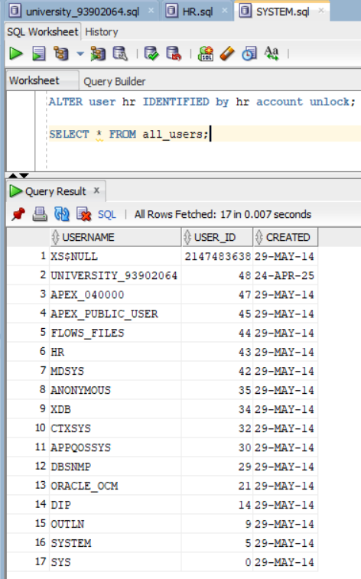**Install and create the HR Schema**

**Find the list of all the employees who earns not less than 25000**

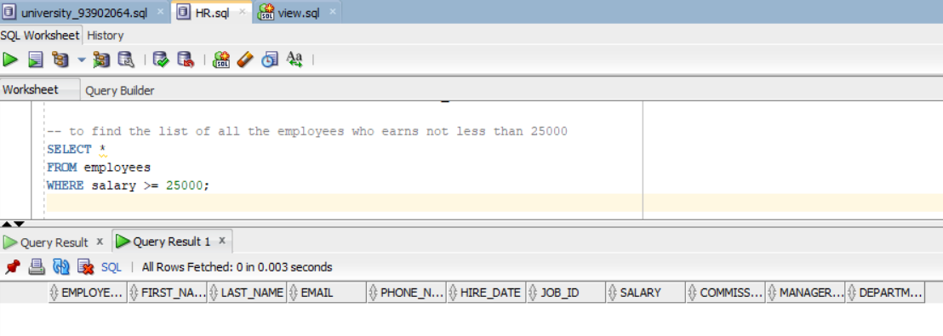

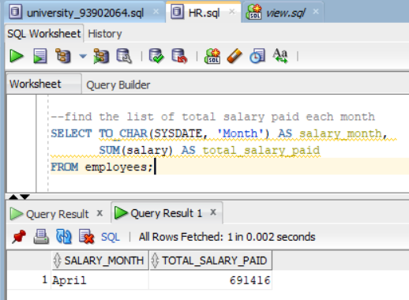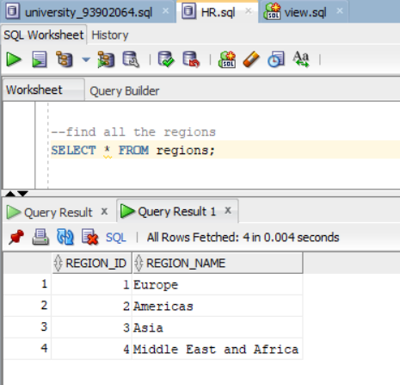**Find all the regions Find the list of total salary paid each month**

**Find the list of total salary paid each month in each department**

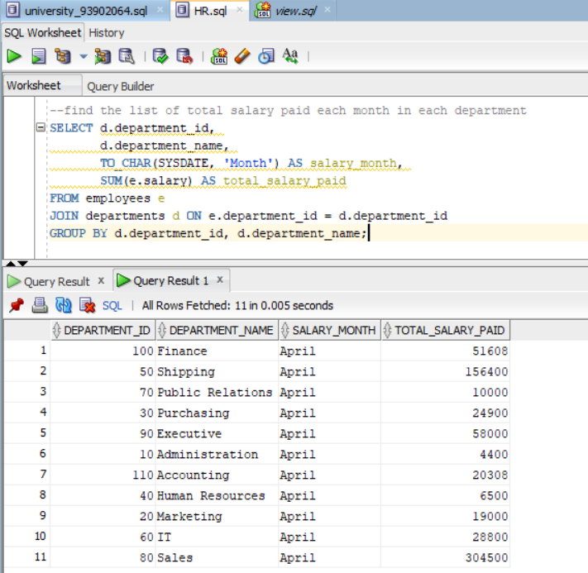

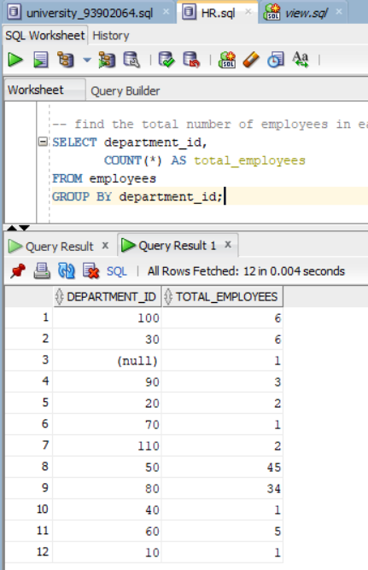**Find the total number of employees in each department**

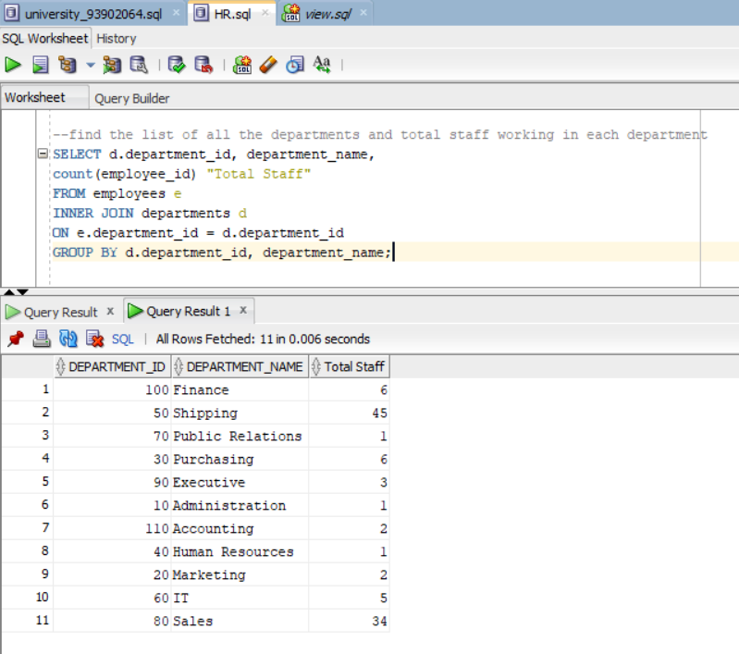**Find the list of all the departments and total staff working in each department**

**Find the list of all the employees who earns more than the average salary [sub-query]**

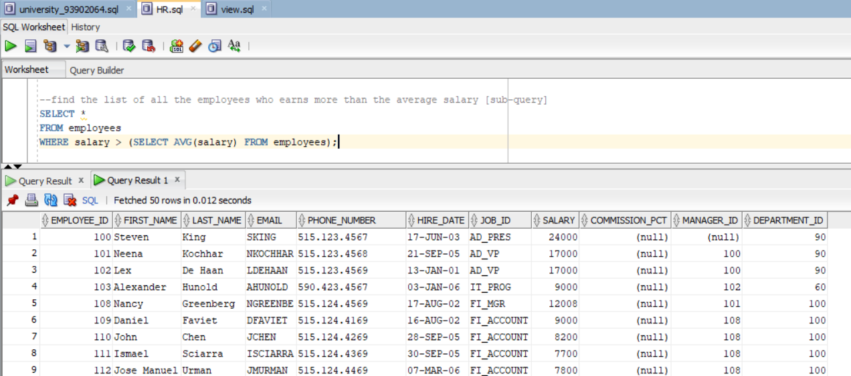

**Find the list of all the employees who is from department_id 10, 30, 50 [OR operator, IN Operator]**

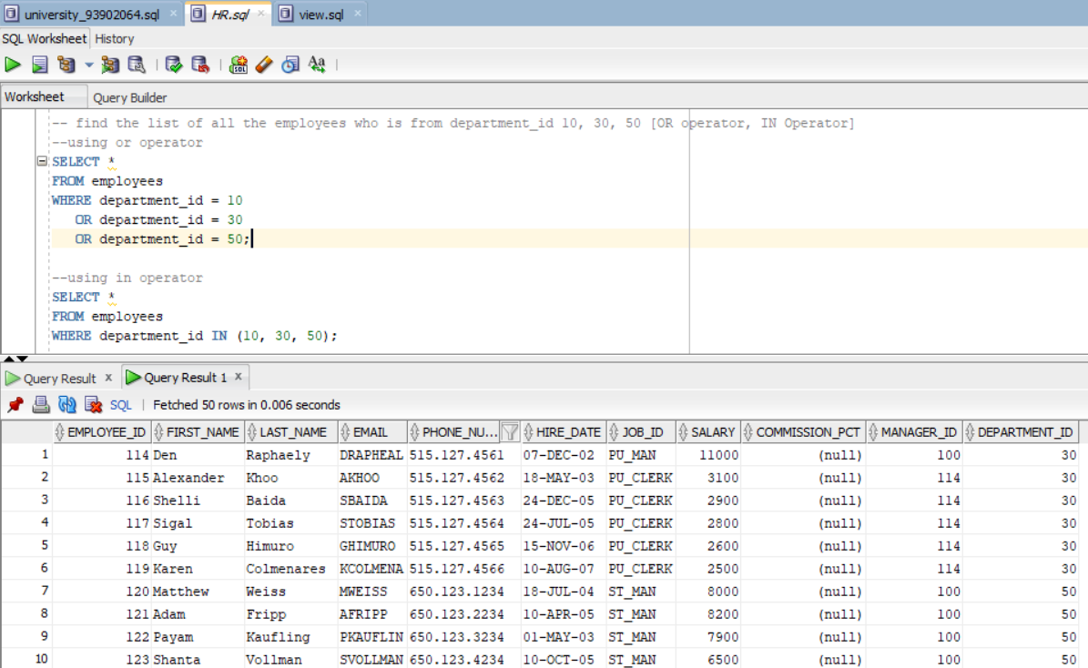

**Find the list of all employees who earns between 2500 & 5000 [Between operator]**

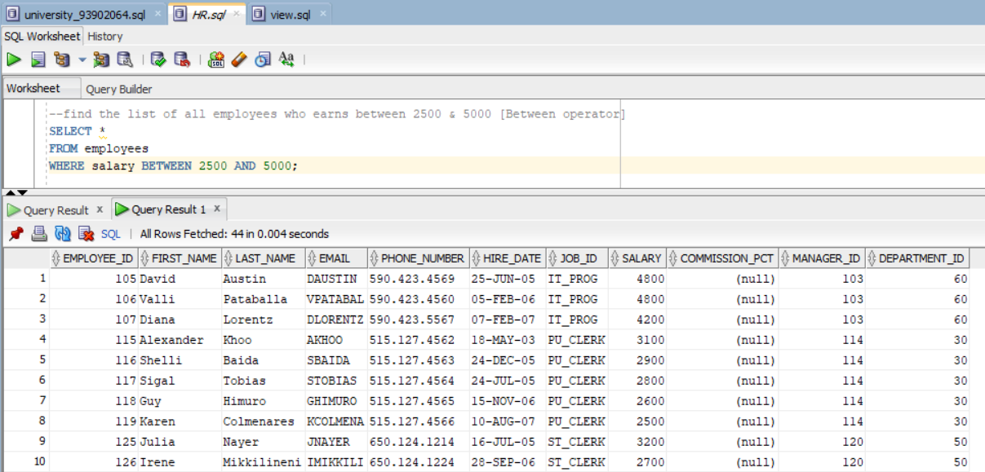

**Find the list of all the regions and total staff in that region**

